**Negative Use Case**

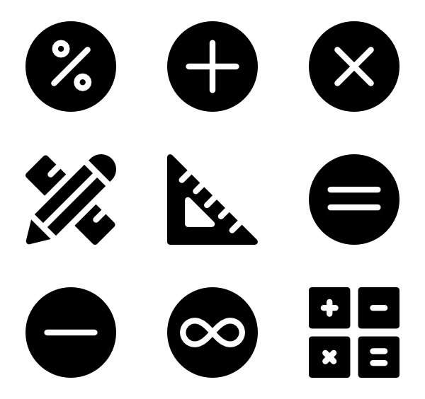**Requirements**:

* Must be using a scientific calculator (ie. A calculator with trigonometric functions)

**Scenario**:

User is imputing their calculations to retrieve a solution but they are unable to use the calculator correctly.

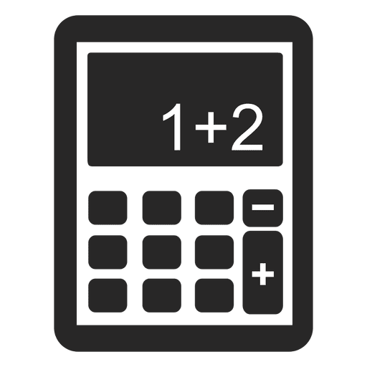

1. The Calculator is in the incorrect mode to accurately complete the calculation.
2. Rounding variables only at the conclusion of the calculation.
3. Not using brackets on division calculations.

**Elaboration**:

1. “Calculator is in the incorrect mode…”

In this scenario, the user for example, may forget to switch to the proper mode of the calculator (see calculator manual for more information). Basic modes included are usually Computational, Degrees and Normal.

1. “Rounding variables only at the conclusion of the calculation. “

It is good practice during the calculation process to store every step of the calculation in the memory. The user needs to account for ALL decimal places to ensure summation accuracy.

1. “Not using brackets on division calculations.”

Like any mathematical calculation with specified brackets, the same rules apply when using a calculator to solve a bracketed problem; any variable in between the brackets is dominate.

**Findings**

It is important that the user be provided with a detailed manual when using a scientific calculator. A manual detailing the function locations, custom capabilities of the specified calculator with a concise overview of a user handling guide will impede negative use cases.